

|  |  |  |  |  |  |  |  |  |
| --- | --- | --- | --- | --- | --- | --- | --- | --- |
|  | | | | | | | | |
|  | | DB Lab 07 | | | | |  | |
|  |  | | | | | | |  |
|  | | | |  |  | | | |
|  | | | | Basil Ali Khan(20K-0477) |  | | | |
|  | | | | 10 October 2022—Database And Management System Lab—Sir Ahmed Budhi |  | | | |
|  | | |  | | |  | | |

Exercise#01:

Task#01:

set SERVEROUTPUT ON;

DECLARE

num1 INTEGER;

num2 INTEGER;

result INTEGER;

BEGIN

num1:= &num1;

num2:= &num2;

result:= num1+num2;

dbms_output.put_line('The sum is '||result);

END;

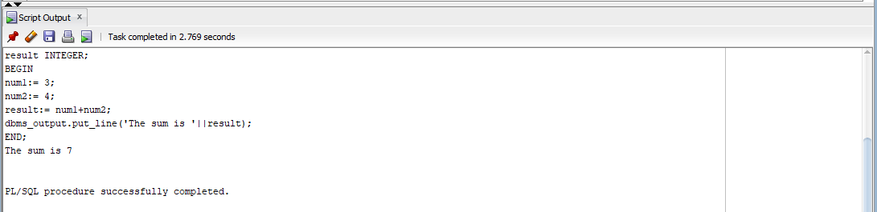

Task#02:

set SERVEROUTPUT ON;

Declare

lower_boundary INTEGER;

upper_boundary INTEGER;

result INTEGER;

Begin

lower_boundary:= &lower_boundary;

upper_boundary:= &upper_boundary;

result:= 0;

for i in lower_boundary .. upper_boundary loop

result:=result + i;

END LOOP;

dbms_output.put_line('The Sum is '||result);

End;

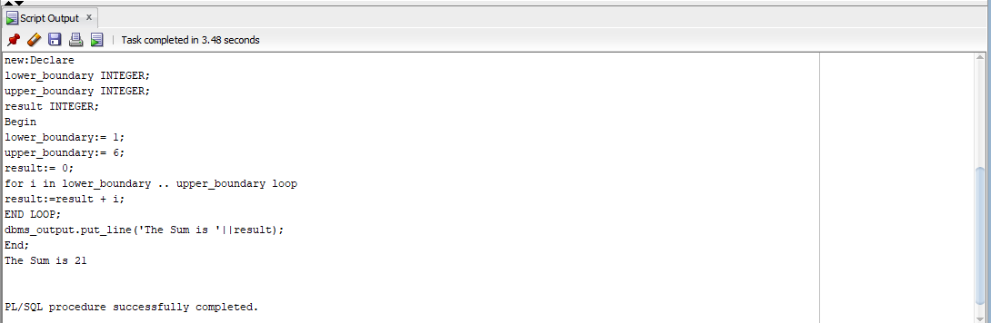

Task#03:

set SERVEROUTPUT ON;

Declare

fname HR.EMPLOYEES.FIRST_NAME%type;

hdate HR.EMPLOYEES.HIRE_DATE%type;

deptname HR.DEPARTMENTS.DEPARTMENT_NAME%type;

input INTEGER;

Begin

input:= &input;

SELECT e.FIRST_NAME ,e.HIRE_DATE,d.DEPARTMENT_NAME into fname, hdate , deptname

FROM HR.EMPLOYEES e join HR.DEPARTMENTS d On e.department_id= d.department_id

WHERE EMPLOYEE_ID=input;

dbms_output.put_line(' The Name of employee is '||fname);

dbms_output.put_line(' The Hiredate of employee is '||hdate);

dbms_output.put_line(' The Department name of employee is '||deptname);

End;

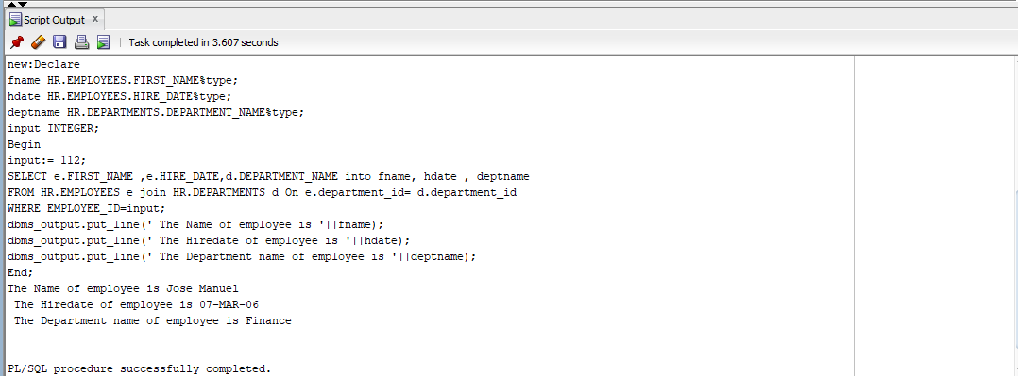

Task#04:

Set SERVEROUTPUT ON;

Declare

num1 INTEGER;

num2 INTEGER;

temp INTEGER;

rem INTEGER;

Begin

num1:=&num1;

num2:=num1;

temp:=0;

while num1>0

loop

rem:=mod(num1,10);

temp:=(temp*10)+rem;

num1:=trunc(num1/10);

end loop;

if num2 = temp

then

dbms_output.put_line('The Number is Palindrome');

else

dbms_output.put_line('The Number is not Palindrome');

end if;

END;

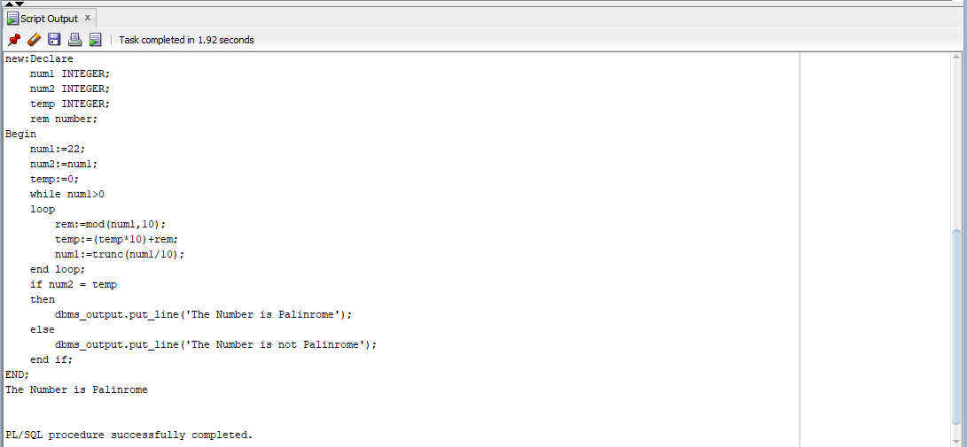

Task#05:

Set SERVEROUTPUT ON;

Declare

empid HR.EMPLOYEES.EMPlOYEE_ID%type;

fname HR.EMPLOYEES.FIRST_NAME%type;

lname HR.EMPLOYEES.LAST_NAME%type;

email HR.EMPLOYEES.EMAIL%type;

phone HR.EMPLOYEES.PHONE_NUMBER%type;

hdate HR.EMPLOYEES.HIRE_DATE%type;

jobid HR.EMPLOYEES.JOB_ID%type;

salary HR.EMPLOYEES.SALARY%type;

manager HR.EMPLOYEES.MANAGER_ID%type;

deptid HR.EMPLOYEES.DEPARTMENT_ID%type;

deptid1 HR.DEPARTMENTS.DEPARTMENT_ID%type;

deptname HR.DEPARTMENTS.DEPARTMENT_NAME%type;

loc HR.DEPARTMENTS.LOCATION_ID%type;

Begin

empid:=&empid;

fname:='&fname';

lname:='&lname';

email:='&email';

phone:='&phone';

hdate:='&hdate';

jobid:='&jobid';

salary:=&salary;

manager:=&manager;

deptid:=&deptid;

deptid1:=&deptid1;

deptname:='&deptname';

loc:=&loc;

INSERT INTO HR.EMPLOYEES(employee_id, first_name,last_name,email,phone_number,hire_date,job_id,salary,manager_id,department_id)

VALUES (empid,fname,lname,email,phone,hdate,jobid,salary,manager,deptid);

INSERT INTO HR.DEPARTMENTS(DEPARTMENT_ID, DEPARTMENT_NAME, LOCATION_ID)

VALUES (deptid1, deptname, loc);

End;

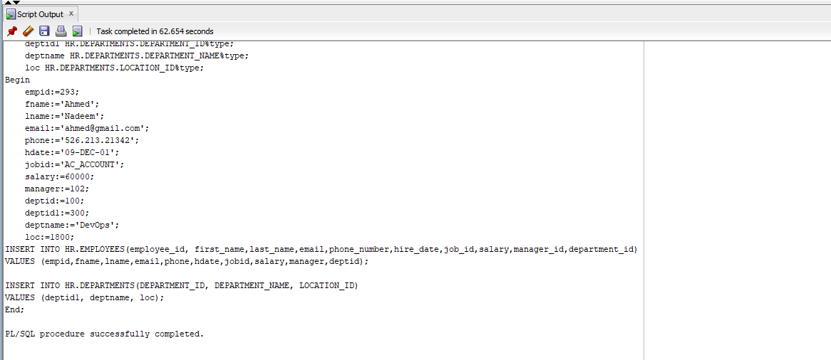

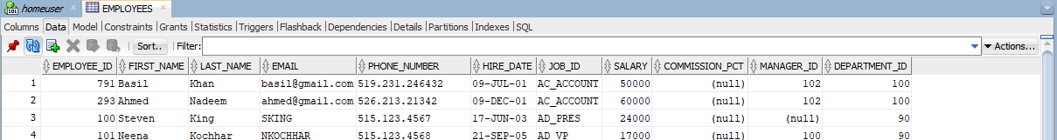

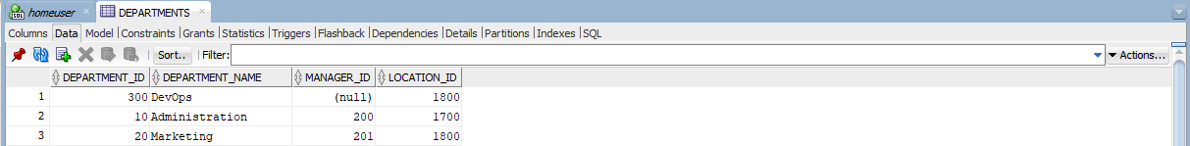

Task#06:

set SERVEROUTPUT ON;

DECLARE

empid HR.EMPLOYEES.EMPLOYEE_ID%TYPE := 168;

salary HR.EMPLOYEES.SALARY%type:=0;

managerid HR.EMPLOYEES.MANAGER_ID%type;

BEGIN

dbms_output.put_line('EMPLOYEE ID: '||empid);

SELECT MANAGER_ID

INTO managerid

FROM HR.EMPLOYEES

WHERE EMPLOYEE_ID = empid;

WHILE SALARY <= 2500

LOOP

SELECT SALARY, MANAGER_ID

INTO salary, managerid

FROM HR.EMPLOYEES

WHERE EMPLOYEE_ID = managerid;

dbms_output.put_line('Manager: '||managerid);

dbms_output.put_line('Salary: '||salary);

END LOOP;

END;

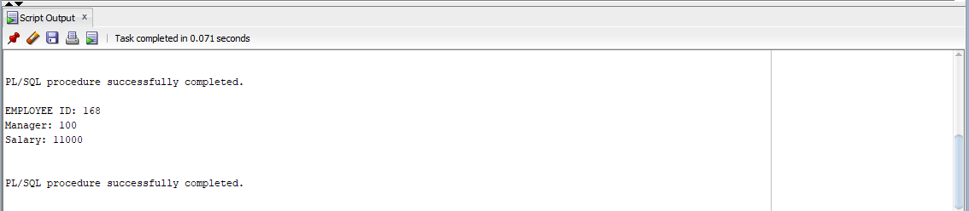

Task#07:

set SERVEROUTPUT ON;

Declare

sum1 INTEGER;

Begin

sum1:=0;

for i in 1..100

Loop

sum1:=sum1+i;

End Loop;

dbms_output.put_line('Sum of First 100 numbers is '||sum1);

END;

